Arduino Experiment

Subject:  Related Subjects: | Grade Level(s):  Length of Lesson: | Type: Inquiry / Design / Project  Keywords:

Lesson Overview
Use this section to describe at a high level what the lesson is. Should be no more than 3-4 lines.

Lesson Focus
What is the central question or phenomenon being investigated? What problem are they trying to solve?

Lesson Objective(s) | - Learn and define electrical circuits  - Begin to understand how the Arduino code works  - Connect experiment with real world examples  - Complete your circuit and try it out!

Lesson Timing

5 minutes | Introduce the Lesson
30 minutes | ...

Materials | - LED  - 3- Jumper wires  - 1- RedBoard  - 1- 330 Ohm resistor  - 1- Breadboard
Instructor Prep | - Step 1
Related Resources | - List related lessons/ppts etc available from USC or outside, trusted orgs

Lesson Plan

Introduction

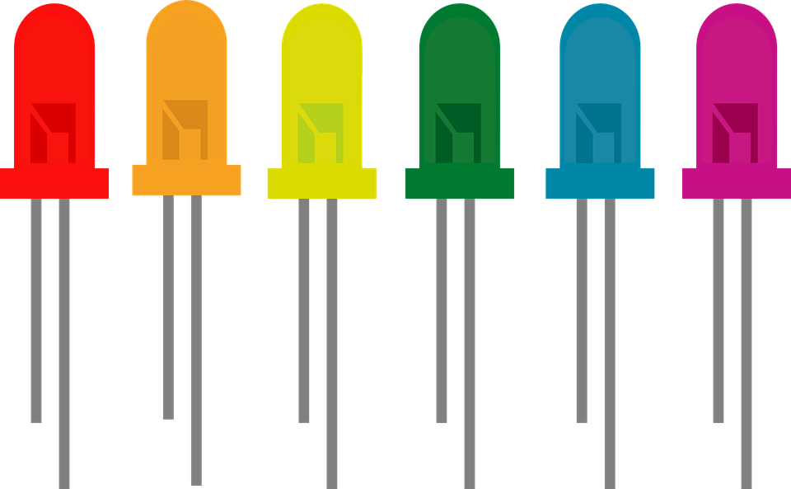
LEDs are small, powerful lights that are used in many different applications. To start off, we will work on blinking an LED. Turn an LED on for one second, off for one second, and repeat forever!
Real World Examples: Almost all modern flat screen televisions and monitors have LED indicators lights to show they are on or off.

Procedure
- Assemble- Screw the RedBoard down and into place and peel sticker off back of breadboard and stick into place. Connect the USB cable.
- LED- Insert LED into breadboard sockets c2 (long leg) and c3 (short leg).
- Resistor- Insert resistor in breadboard socket a3 and in any socket with the “-” symbol in a vertical position.
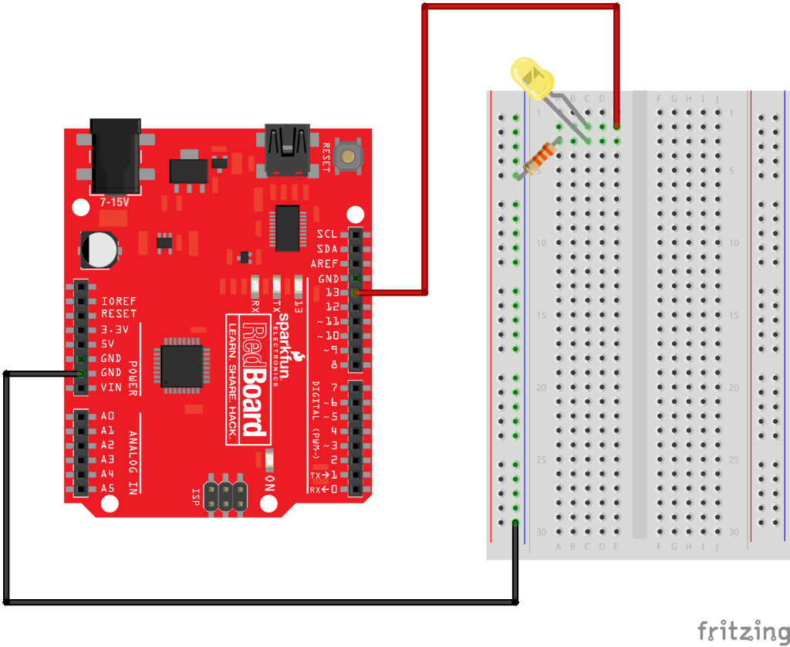
- Jumper wires- Use a jumper wire to connect the “GND” on the RedBoard to one of the sockets in the row marked “-” on the breadboard.
  - Use another jumper wire to connect the “5V” on the RedBoard to one of the sockets in the row marked “+” on the breadboard (optional).
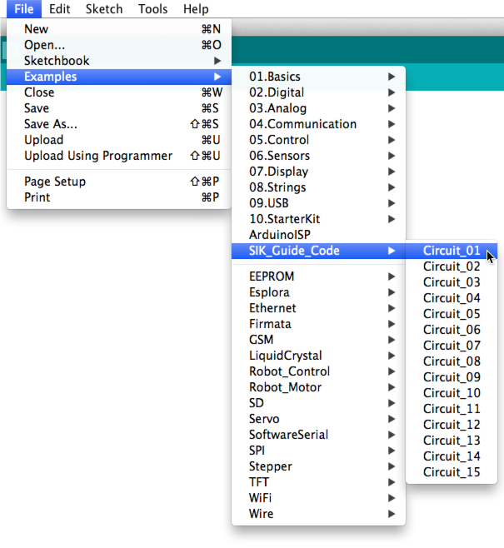
  - Use the last wire to connect the “Pin 13” on the RedBoard to socket “e2” on the breadboard.
- Open your first sketch- Open up the Arduino software in your computer and open the code for Circuit 1 by accessing the “SIK Guide Code” that was placed into your “examples” folder.
- Look at your code: Before you can use one of the Arduino’s pins, you need to tell the RedBoard whether it is an input or output. We use a built-in “function” called pinMode( ) to do this. We need to send voltage “out” of Arduino to the LED so we will set up pin 13 to be an output.
pinMode(13, OUTPUT);
digitalWrite( ) is the built-in function we use to make an output pin HIGH (output 5 volts) or LOW (output 0 volts).
digitalWrite(13, HIGH);
delay( ); is a function that pauses for a given amount of time. It is measured in milliseconds, so if you delay(1000), it will pause for exactly one second.
- Verify and upload!

Wrap-up
- What happens when you change the 1000 in the delay( ) function to different numbers? How does it affect the timing?

What you should see
You should see your LED blink on and off. If it isn’t, make sure you have assembled the circuit correctly and verified and uploaded the code to your board.

Lesson Background for Teachers

Suggested Real-World STEM Connections
- List possible related Role Models in STEM (with details and links to more reading). Give suggestions for examples of scientists/engineers who are from underrepresented groups in STEM in related careers.
- List related real-world engineering problems and examples

Lesson Variations and Options
Include descriptions of alternative methods or ways to present things.

Explanation
Describe the background concepts and explanations behind the lesson. This can be more in depth than a teacher/instructor would actually share with students.

Key Concepts and Vocabulary
- Electrical circuit- a circuit is basically an electrical loop with a starting point and an ending point - with any number of components in between
- Diode- an electronic device, as a two-element electron tube
- Light-Emitting Diodes (LEDs)- a particular type of diode that convert electrical energy into light
  - The negative side of the LED is the short leg (cathode) and the positive side of the LED is the long leg (anode).
- Resistors- a device that is used to control the flow of electricity in an electric circuit

Safety Notes
- Safety instruction

